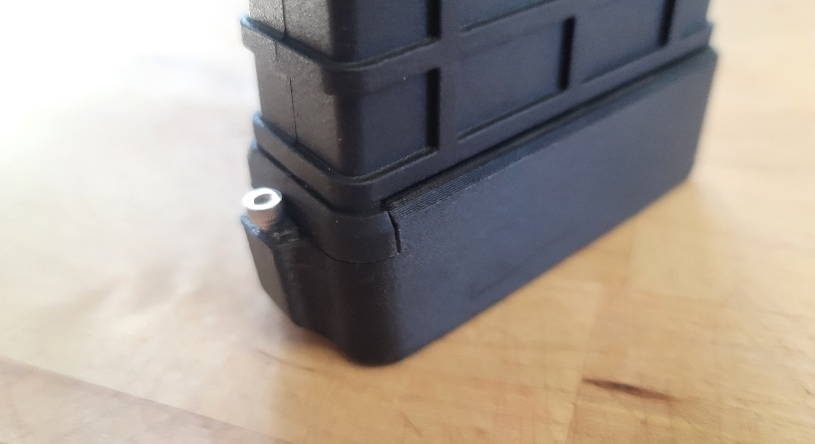

# Tools Needed:

**

**Step 1:**

Depress MDT Mag plate and slide factory bottom plate

*Caution: Follower is under spring pressure, keep thumb on plate to prevent plate from flying out when factory bottom mag plate is removed

**Step 2:**

Prepare new mag extension by removing the 2.5mm Allen screw using a 2.5mm allen wrench

**Step 3:**

While depressing follower plate, Align mag extension rails to MDT mag and slide forward until rear lip snaps over the mag

**Step 4:**

Use 2.5mm Allen T handle wrench to align mag follower plate into mag extension hole

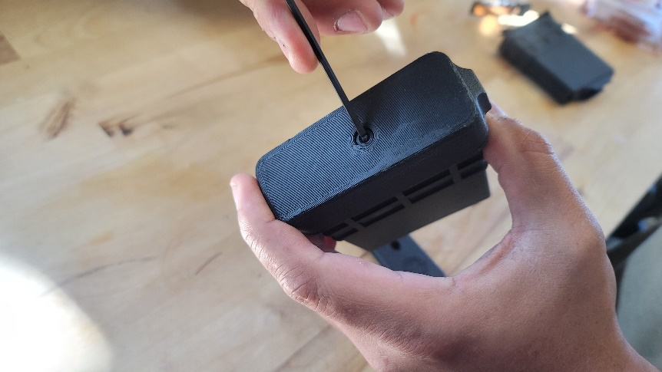

**Step 5:**

Install 2.5mm Allen screw into rear mag extension. This screw will prevent extension from unintentionally sliding forward

**CAUTION TO NOT OVER TIGHTEN**

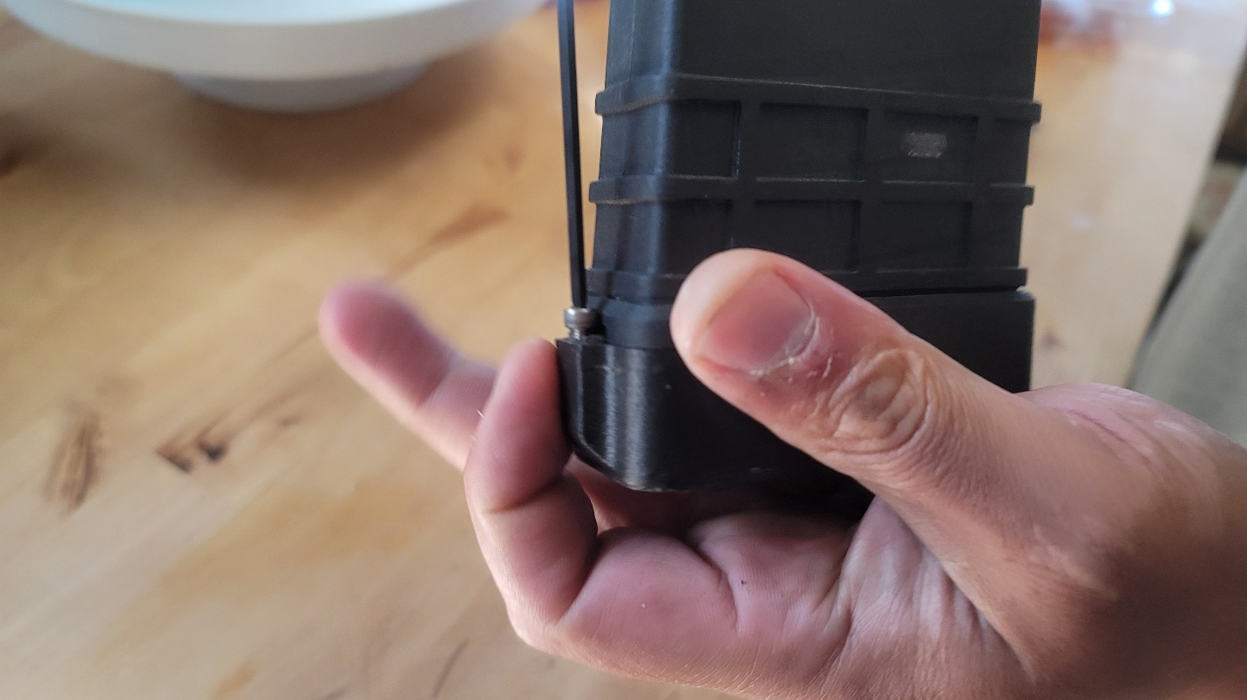

**FINISH**