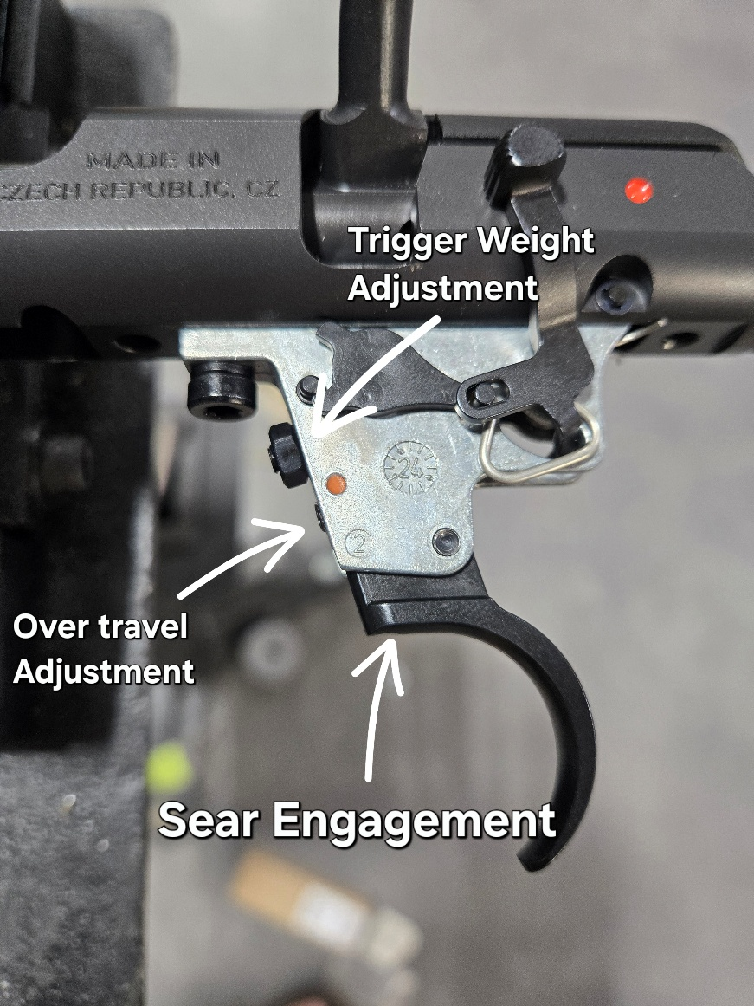
Tools Needed:
Small Cresent Wrench
1.5mm Allen
2.0mm Allen
1/8in Punch

DPGunworks Disclaimer
Improper handling, installation, storage and/or use of DPGunworks products and/or the firearm in which they are installed, can cause death, serious injury and/or property damage.
DPGunworks products are designed solely for installation and use in the specific firearm for which they are advertised. It is the purchaser’s responsibility to determine compatibility.
Aftermarket trigger handling and installation can involve complicated procedures and presuppose knowledge of firearms handling. If a purchaser or user is not familiar, or not sufficiently familiar, with firearms handling and exchanging out trigger components, the purchaser or user (collectively, “Purchaser”) must seek further information and assistance from a gunsmith or other qualified professional.
By installing or using any purchased DPGunworks trigger product (“DPG”) the Purchaser agrees to the following terms and conditions: 1.The Purchaser will abide by all applicable firearm safety laws, protocols, and regulations in force in the jurisdiction where the DPG Product is handled, installed, stored and/or used; 2. The Purchaser certifies that he/she is legally entitled to purchase and use the DPG Product and the firearm in which it is to be installed, in the jurisdiction where the DPG Product is purchased and used; 3. The Purchaser assumes responsibility for ensuring that any users of the DPG Product comply with these terms and conditions and with all applicable firearms safety protocols and regulations when handling, installing, storing and/or operating the DPG Product; 4. The Purchaser agrees to conduct a test for proper trigger fit and function, before each use of the DPG Product, with the firearm in which it is installed in an unloaded condition. Never assume the DPG Product works without testing it; 5. The Purchaser agrees to consistently use a trigger lock on the installed DPG Product, together with any related safety mechanism on the firearm in which the DPG Product is installed; 6. The Purchaser agrees to contact DPGunworks immediately in the event of any change or loss of trigger function; 7. In no event shall DPGunworks be liable for any direct, indirect, incidental, special, consequential or punitive damages arising from loss of life, personal injury and/or property damage, in connection with the use or misuse of the DPG product, or the firearm in which the DPG Product is installed; 8. DPGunworks is not responsible for the acts or omissions of the Purchaser resulting from a lack of training or knowledge of firearms handling, or failure to properly implement such training and knowledge; 9. The Purchaser assumes the risk and all liability for death, injury, and loss and damage to persons or property caused by use or installation inconsistent with DPGunworks instructions, negligent or intentional use or misuse of the DPG Product, or the firearm in which the DPG Product is installed.

- Ensure rifle is clear and safe before installation of the DPG PMT Trigger Shoe Upgrade
- Remove Barreled action from stock/chassis
- Remove Bolt Assembly from action
- Remove Magazine bottom metal housing to access trigger adjustment screws easier
- On factory trigger housing crack loose the jam nut on the trigger weight adjustment screw, completely remove trigger weight adjustment screw and jam nut. Set aside for now
- Drive 3mm / 1/8in pin that is holding the factory trigger shoe from Left to Right
- Remove factory trigger shoe and spring that sits in the pocket of the factory trigger shoe
- Install the new DPG PMT Trigger Shoe and drive the 3mm / 1/8in Pin from Right to Left to hold the shoe
- Insert our provided trigger weight spring through the threaded hole of the trigger weight adjustment. Our spring should sit inside the pocket of our trigger shoe and sit flush to the trigger housing
- Re-install the trigger weight adjustment screw with Jam nut loose
- Install your Bolt Assembly and test trigger will fire
- Adjust trigger pull weight to desired pull weight before making the following adjustments
- Adjust over travel screw to your preference. Do not over tighten this screw or your trigger shoe will not disengage and allow the trigger to fire. Back out this screw for more over travel. Screw in tighter to reduce. This adjustment only needs minor adjustment
- On factory trigger shoe, remove the 3mm sear engagement screw with a 1.5mm allen.
- Install the factory 3mm sear engagement screw into the new DPG PMT Trigger Shoe
- Adjust 3mm sear engagement screw with the trigger in the cocked position. Slowly screw in this screw until the trigger trip
- Rotate sear engagement screw counter clockwise 180* to set proper sear engagement (WARNING!!! having to little sear engagement can result in a slam fire or accidental discharge). Only adjust this screw tighter from 180* while testing for safe function of the firearm
- Re-install Mag Well housing
- Re-install barreled action to chassis/stock
- Test for safe function of the firearm by bumping buttstock. Test safety selector functions

